# **HR leavers data analysis**

Attrition may be an interesting metric, but how much of this attrition rate consists of regretted loss?

“You wouldn’t bat an eye when a bad performer leaves, but it’s like shooting yourself in the foot when the one who leaves is a high performer and potentially senior management material.”

Interactive dashboards enable you to drill down into your data and make these observations and pulse of the organisations by tracking key workforce metrics. New trends and opportunities can be spotted early on, and emerging problems addressed before they significantly impact the business.

# Slide-1

Employees quit for many reasons. Staff stay in the same grade for extended periods of time without promotion is one of the primary factors for leaving an organisation. The analytical dashboard (Figure1), clearly represents the 99% (3552/3571) of employees left the organisation are haven’t received any promotion over last five years, whereas, a percentage of the employees left the organisations received promotion are lesser than one percent.

Satisfaction is one more significant factor that directly influences the staff attrition. There are infinite reasons for satisfaction, few essential elements are:

* Poor match between the person and the job
* Poor fit with the organisational climate and culture
* Poor alignment between pay and performance
* Poor connections between the individual, their co-workers, and the supervisor
* Fewer opportunities for growth and advancement.

We can identify the relationship between the employee attrition and satisfaction; employees with the lowest satisfaction rate has the highest attrition rate. Likewise, less than 0.5 satisfaction level has a high rate of attrition. One important element shows in Figure.2, an employee with 0.3 satisfaction level shows least attrition rate, as average promotion number is two times. With the general understanding, this effects organisation growth in a negative way and costs considerable expenses regarding salary. “Just because employees are not leaving does not necessarily mean that they are engaged. Studies tell us over 45% of today’s workers are disengaged, costing their employers millions of dollars in lost productivity.”

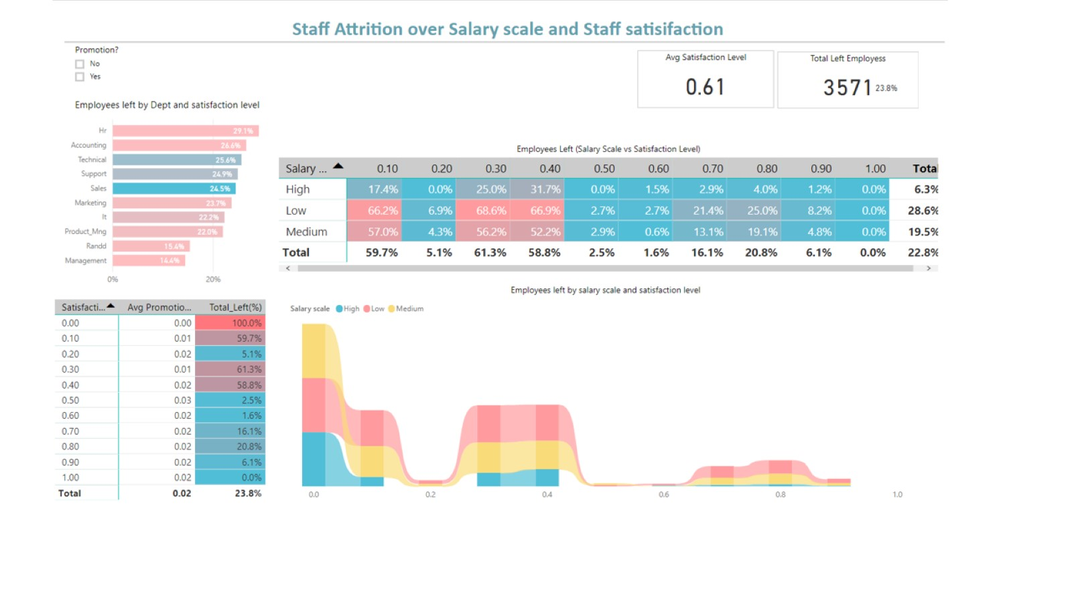

Figure 1. Attrition rate analysis based on salary and satisfaction level.

# Slide-2:

The company's leadership should engage in both proactive and reactive measures to slow the revolving door through which employees depart at a department level. The data analysis at department level offers a great way to track key problem areas transparently. Transparency in attrition rates per department will encourage leaders to pay closer attention to retaining employees.

In Figure.3, dashboard represents employee attrition rate concerning last evolution and salary scale. From the Figure.3, we can identify key features:

* The sales department has highest attrition rate, followed by technical, support and on, whereas least attrition rate.
* Salary scale, Low salary scale has highest attrition rate regardless of department.
* Last evolution rate over employees left rate; maximum left rate noticed at max evaluation rate and intervals: 0.45- 0.57 and 0.77-09 has a significantly high left-over rate.

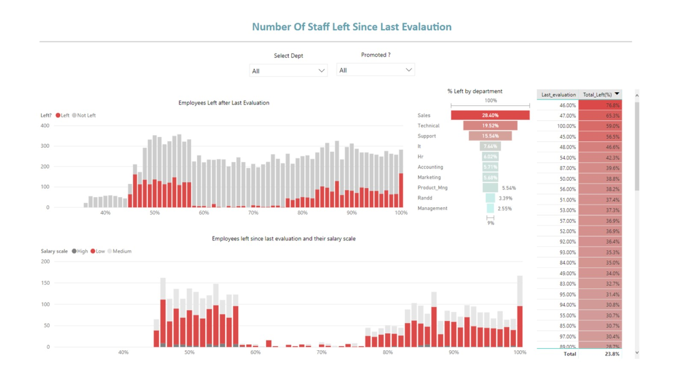

Figure 2. Correlation between attrition rate and last evolution

# Slide-3**:**

Many family friendly policies such as flex-time, reduced hours, working-from-home option, and cut overtime as part of their commitment towards a healthier and more balanced workplace will improve the employee satisfaction level. Additionally, recognising the negative impact on an organisation.

Figure.4, dashboard explains attrition rate over average daily working hours spent. We can identify that the employees working on average at two intervals has low attrition rate: 5.5 – 7 hrs and 3- 3.5 hrs. Likewise, employees of max average working hours have a high rate of attrition (9- 10hrs/day). Negative side, employees of lower working hours has zero attrition rate, which will impact organisation growth negatively (except employees working from home).

Secondly, data analysis on attrition rate over a number of years spent in an organisation represents that, employees at their five years has a highest left rate, followed by 4, 6 and 3. And people over six years has negligible left rate and comparatively less over initial two years.

Thirdly, data analysis on attrition rate over an average number of projects by each department clearly shows that less number of projects (No work) leading to high attrition rates.

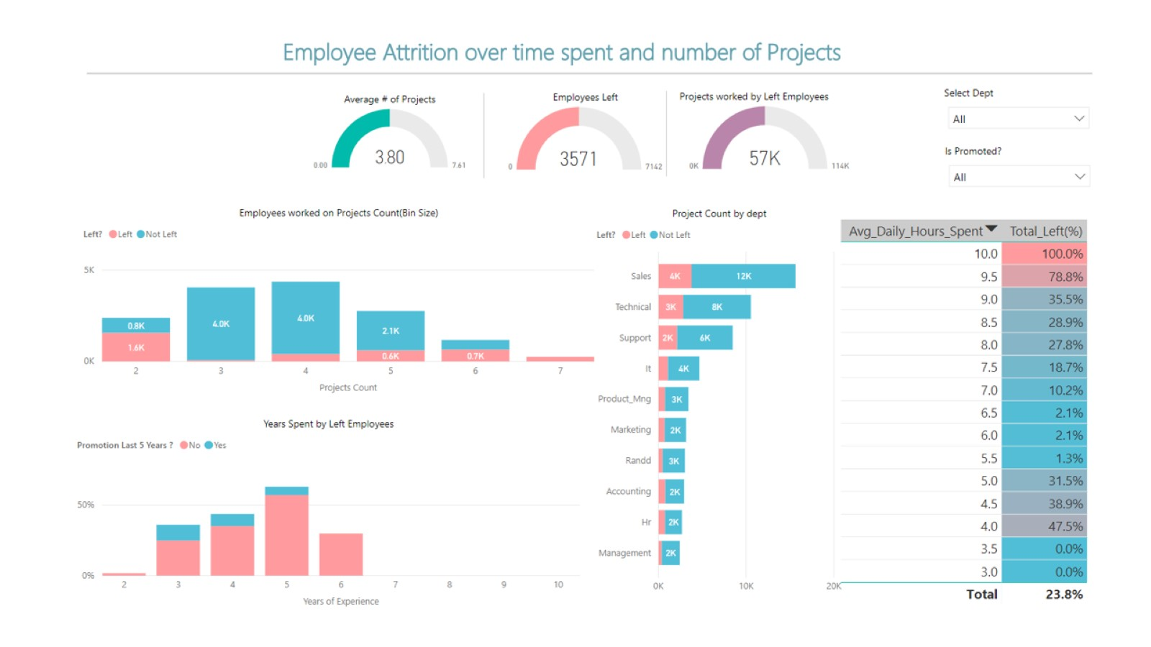

Figure 3. Attrition rate relation with years spent and workload